Erwin WSDL Deployment

# **History of Document**

|  |  |
| --- | --- |
| ***Version*** | ***Changes*** |
| V 1.6 | Pagination issue for non-administrator role in Soap Service Release and make compatible to DIS 10.1. |

Please follow the below instructions to deploy the War (We recommend taking back up of the files before placing any new files)

**1.** Note: Please take back up of three files as mentioned below.

Please navigate to **webapps** folder of Tomcat Directory and go to MetaDataSelector\WEB-INF\classes folder, for ex: the path would be like "<Tomcat Location>\Apache Software Foundation\Tomcat 8.5\webapps\ MetaDataSelector\WEB-INF\classes\ " and find these three files mentioned below and take back up.

* application.properties
* iccdocuments.properties
* database.properties

Note: Please delete the war and folder named as MetaDataSelector from this location "<Tomcat Location>\Apache Software Foundation\Tomcat 8.5\webapps ".

* Please navigate to **webapps** folder of Tomcat Directory, the path would be like "<Tomcat Location>\Apache Software Foundation\Tomcat 8.5\webapps "
* Place the new war file in the above-mentioned location, as provided “war” folder (/CMSWSDL-200121/war in ZIP) after extraction of ZIP folder.
* After placing the war, please do refresh/restart the tomcat.
* Then navigate to **webapps** folder of Tomcat Directory, the path would be like "<Tomcat Location>\Apache Software Foundation\Tomcat 8.5\webapps\ MetaDataSelector \ WEB-INF \classes” and **replace the three files as mentioned in very early part of document numbering with 1.**
* Then open tomcat manager from browser, click on Manager App, next Reload the context path having /MetaDataSelector.
* After the above process, should get this message like below in Tomcat Web Application Manager.

OK - Reloaded application at context path [/MetaDataSelector]

* To Check the application is running or not, navigate the following URL

Ex: http://<ip>:<port>/MetaDataSelector/login

* To Check the soap services are running or not, navigate the following URL

Ex: http://<ip>:<port>/MetaDataSelector/webservice

Then copy the wsdl URL then check in SoapUI, all services are working or not.

**Note**: **Non administrator role should have master access in erwin DIS to access soap service for MDS application**.

1. **Please give default permission on each node for Metadata Manager module in erwin DIS 10.1 for accessing soap service in MDS application for non-administrator role as shown below.**

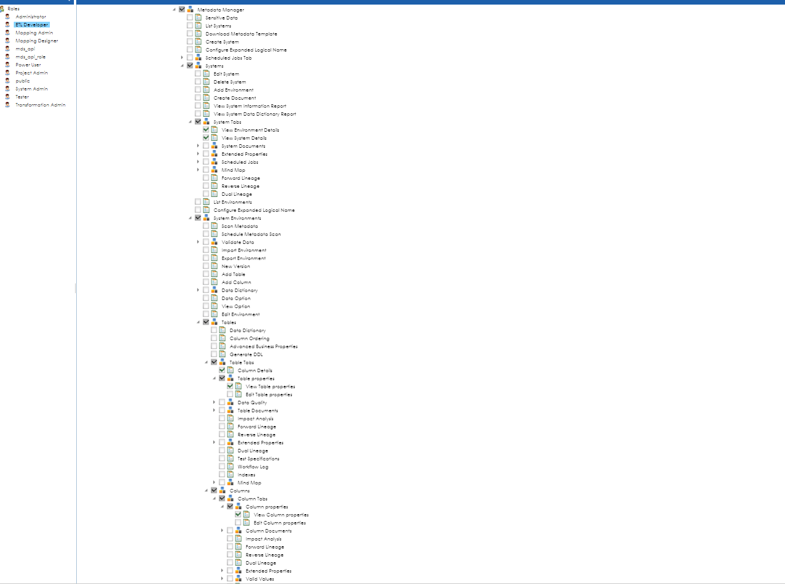

**Thank You.**